Miracle Advance Technologies
HRCT

Document Version No- 1.1.1

Last update Datetime- 04/02/2022

Last update by-Wasiur Rahman

Application User Manual

Application User Manual 3
1. General Information 4
Login as hospital Source 4
Login as PULMO 11
Login as Radiologist 16

1. General Information

Easy viewing and sharing of DICOM images via HRCT-any time and any place. The solution can be set up in a matter of minutes.HRCT provides freedom to manage systems and distribute images.

UML Diagram
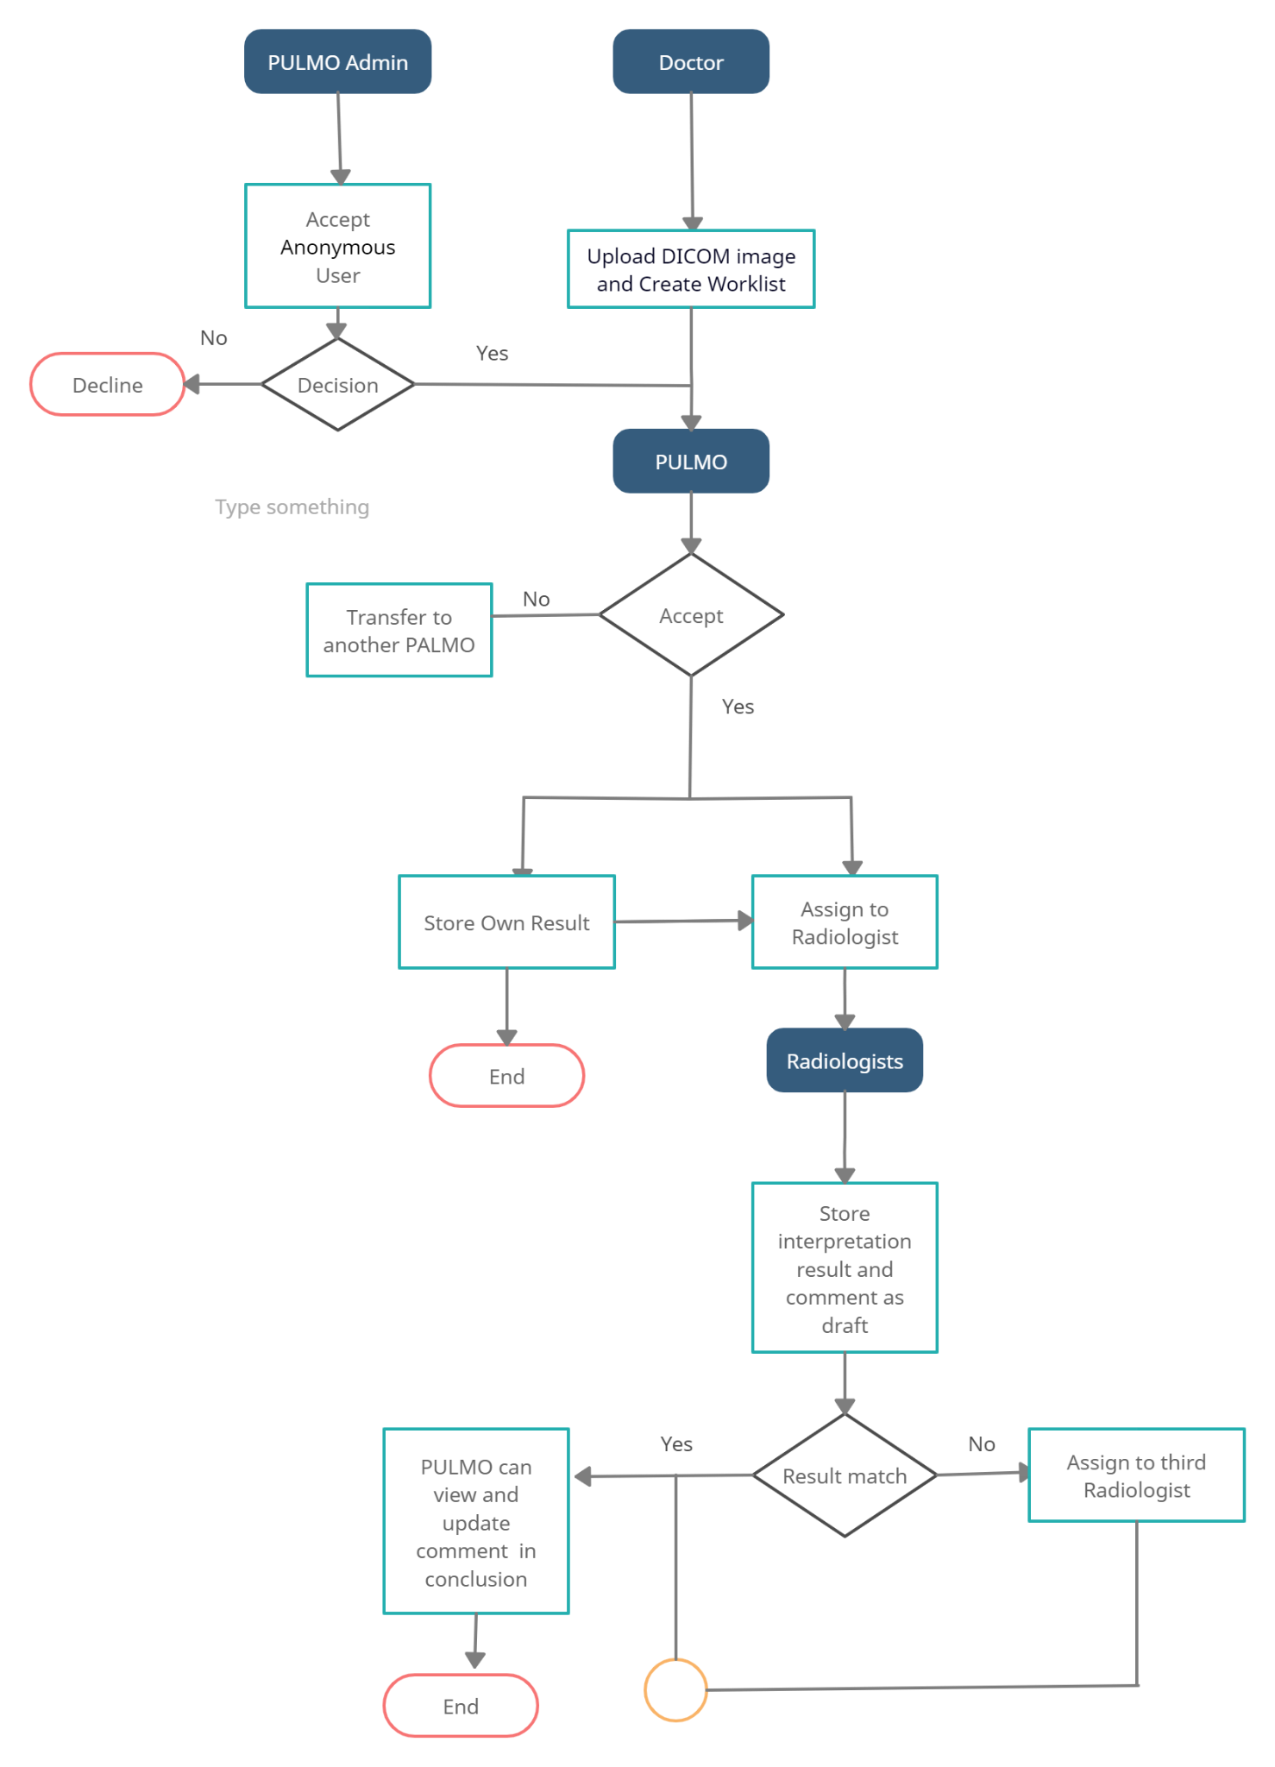

The application focuses on four users.

- Doctors- The doctors can upload DICOM images and create a worklist.

- PULMO- They can store their own results and assign radiologists.

- RADIOLOGIST- The radiologist can interpret results and comments as drafts.

- PULMO Admin- They can accept anonymous users and send the case to another PULMO.

In the HRCT, the doctors login to the system and upload DICOM images to create a worklist. These worklists will be sent to any PULMO (randomly) to finalise the result. The doctors will only see the PULMO’s result and conclusion comment. The PULMO can assign this study between the first and second radiologist. The two radiologists are able to see their assigned study. After successfully assigned the radiologists, PULMO is able to see assigned radiologists in the conclusion tab. Once the first radiologist and second radiologist will finalize their result and if it is not the same, a third radiologist will be assigned. Once the first, second and third radiologist will finalize their results, PULMO will be able to see their results and will be able to update PULMO’s result and enter a conclusion comment and will finalize. After finalizing the result by PULMO, the doctor is able to see the final result. The Anonymous user can create a study worklist, but it will auto disappear if the PULMO admin denies the case.

Login as hospital Source
Hospital source user will login using his/her credentials (user id and password).
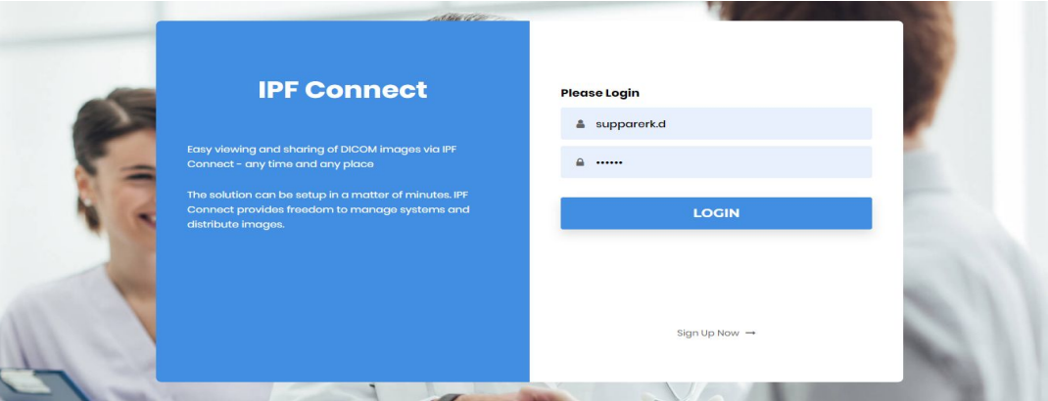

After successful login, the source user will get his/her dashboard. Here users will able to upload DICOM images to create a worklist.

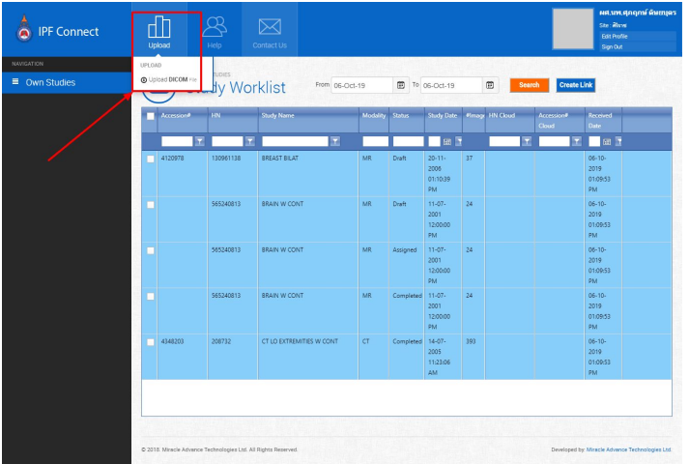

After clicking the Upload DICOM File button, the system will ask to browse the dicom image. Users need to click the “Select” button to browse DICOM image from his/her device.

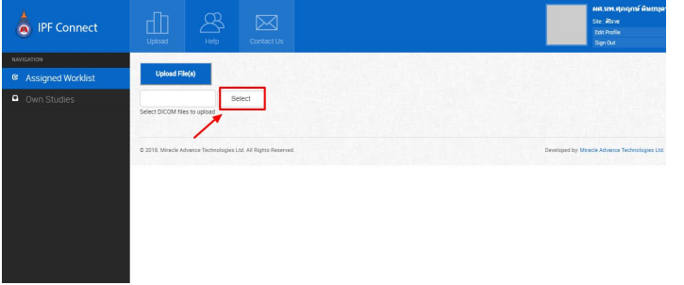

Once a user will select a DICOM image from his/her device, need to click Upload Files button to upload image and a study worklist will created.

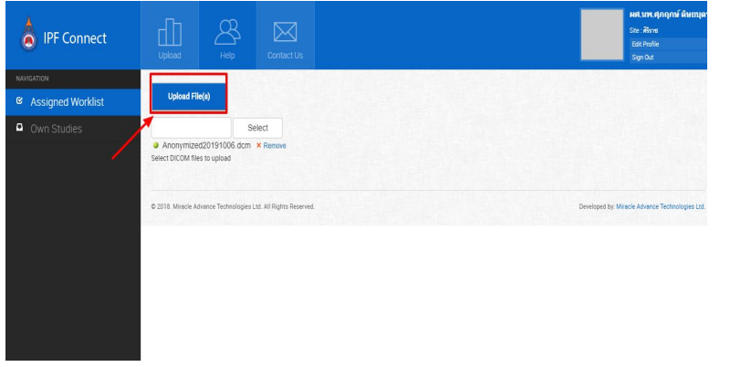

Then the user can able to see his/her created worklist.

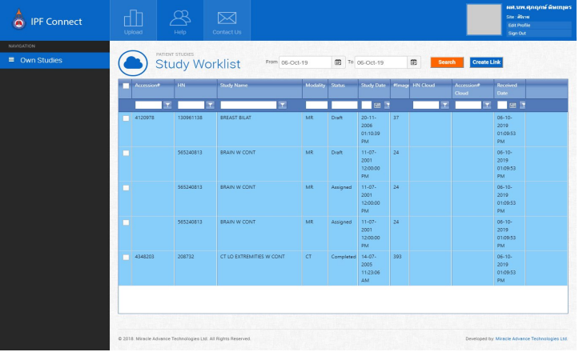

Now users can able to create a link between the two studies.

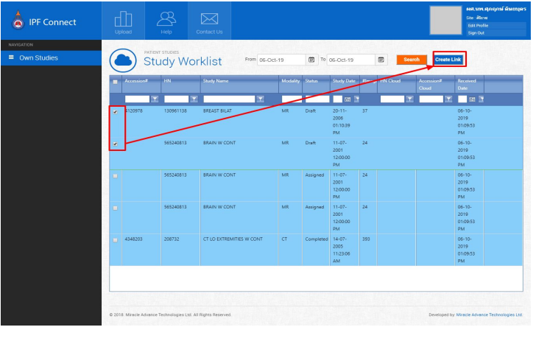
Users are able to store assessment data as a draft or finalise by double clicking the worklist. Once the user will double click on the worklist then the system will open a dialog box to store assessment data. For finalisation assessment data, he/she must have to click at least one radio button.

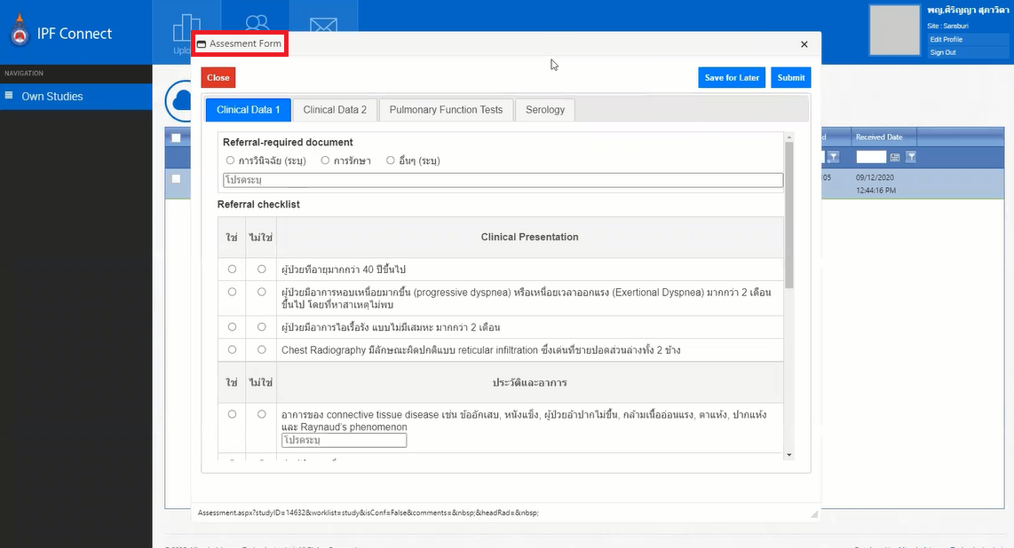

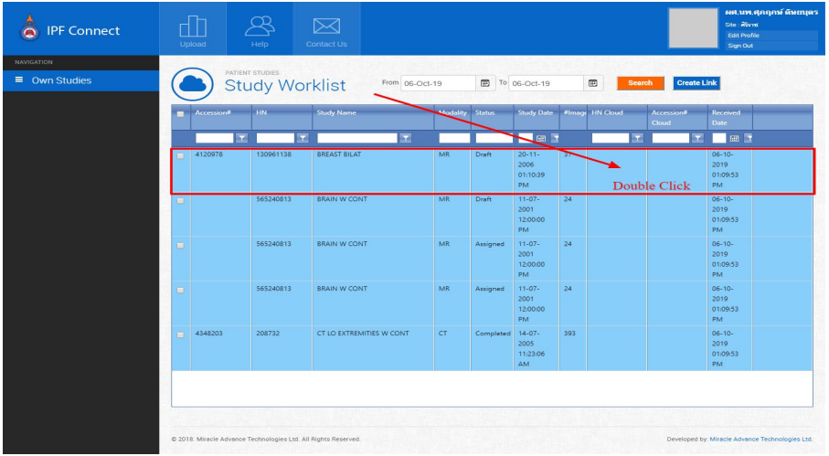
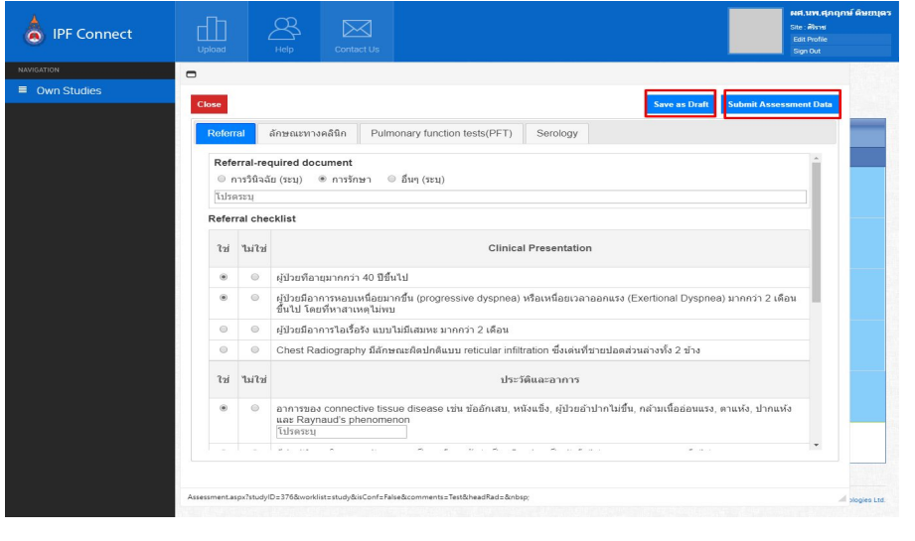
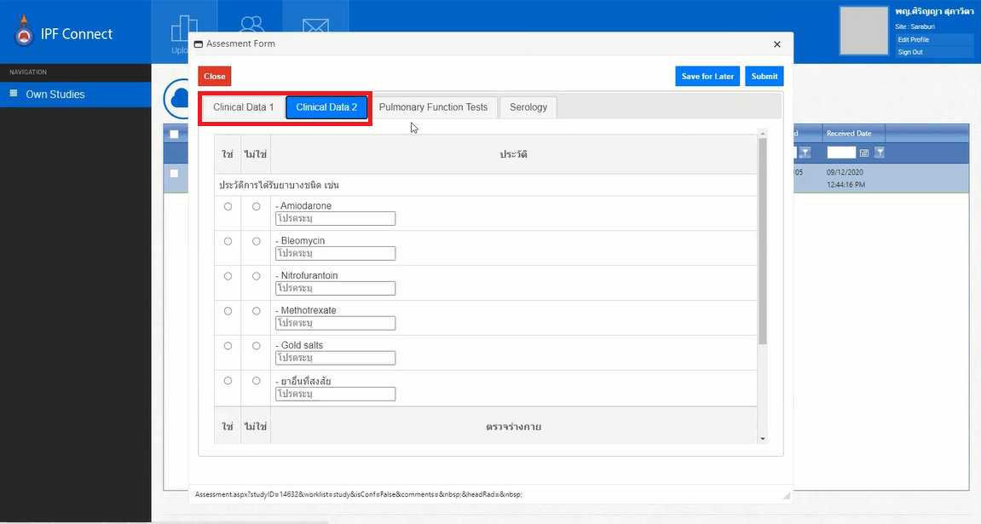

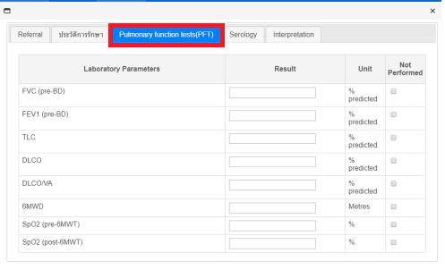

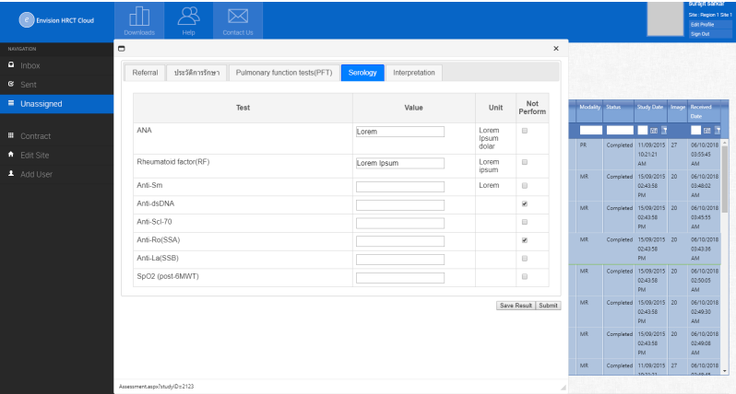

Note: The user must fill up every section of Clinical Data1 and Clinical Data 2.

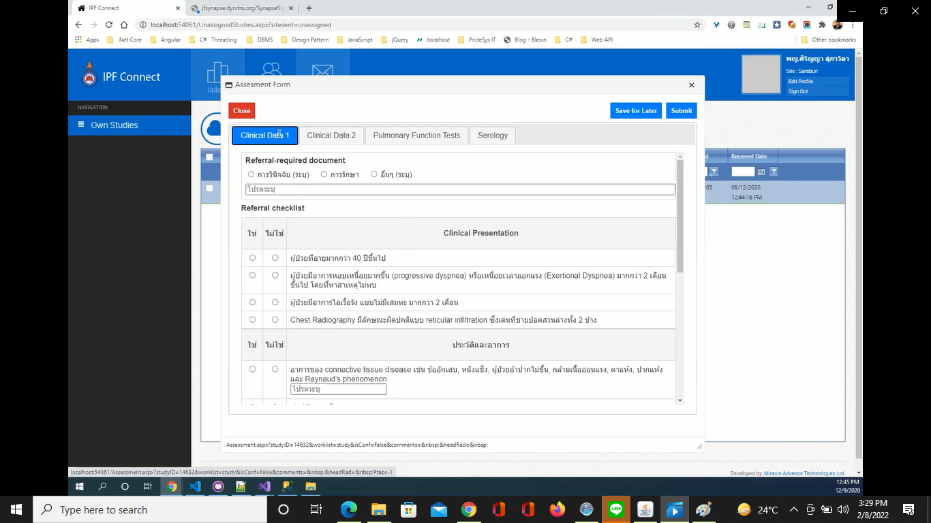

The user can fill up the data later and press the button Save for later. After finishing the assessment form the user has to press the Submit button.

Once PULMO will finalise the result, source user will only see the head node’s result and conclusion comment.

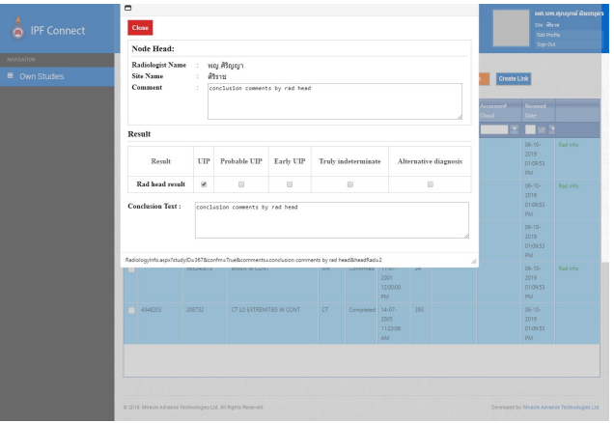

Login as PULMO
PULMO user will login using his/her credentials (user id and password).

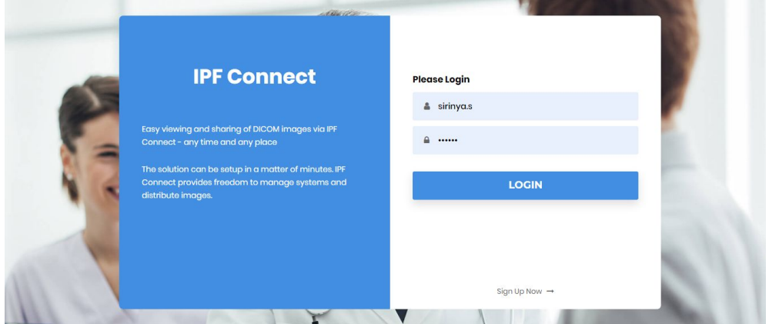

After successful login, PULMO users will get his/her dashboard. Here the user will able to upload dicom image to create worklist and he/she will also get worklist which has been already assigned to him/her.

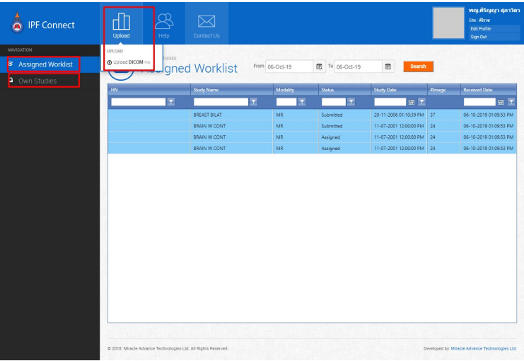

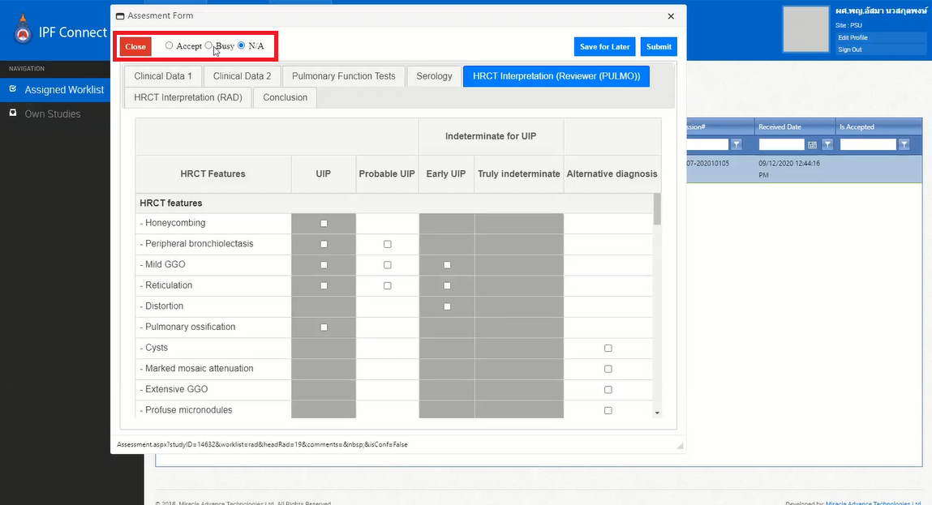

The Pulmo can press Accept, Busy, and N/A. He/She has to click the button sincerely. If they select N/A or Busy, the study will transfer to another Palmo.

If the user will double click in assigned worklist, he/she can only store own result or can assigned this study between first and second radiologist.

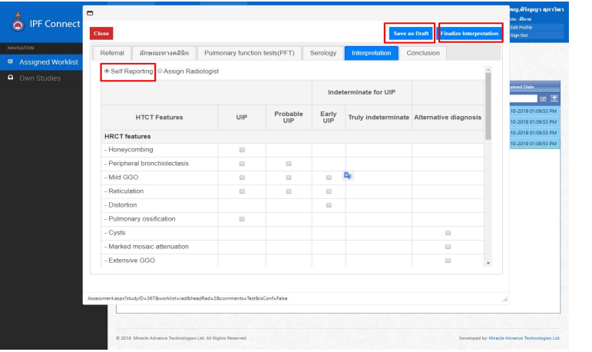

Once user will finalise the interpretation result, he/she can able to see result in conclusion tab.

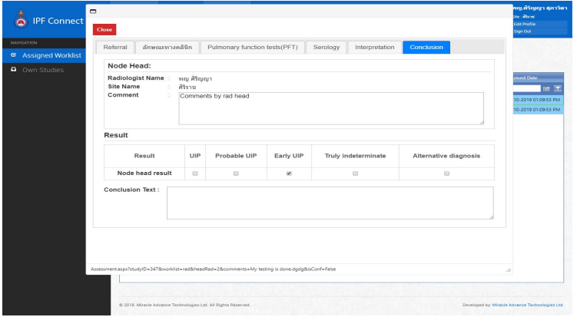

Once a user will assign the study between two radiologists, two radiologists can able to see their assigned study.

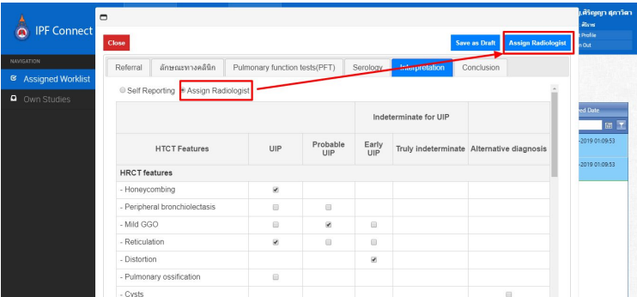

After successful assigned the radiologists, PULMO can able to see assigned radiologists in conclusion tab.

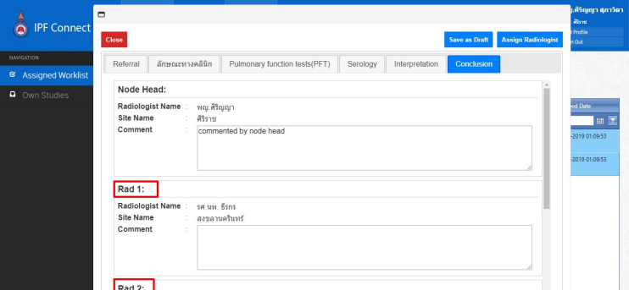

Once first radiologist and second radiologist will finalise their result and if it is not the same, third radiologist will be assigned.

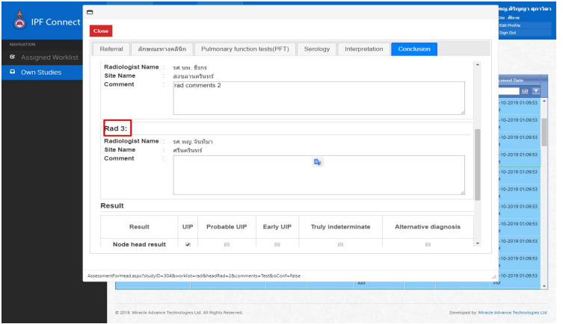

Once the first, second and third radiologist will finalise their results, PULMO users will be able to see their results and be able to update PULMO’s result and enter conclusion comments and will finalise. After finalise result by PULMO, source can able to see the final result.

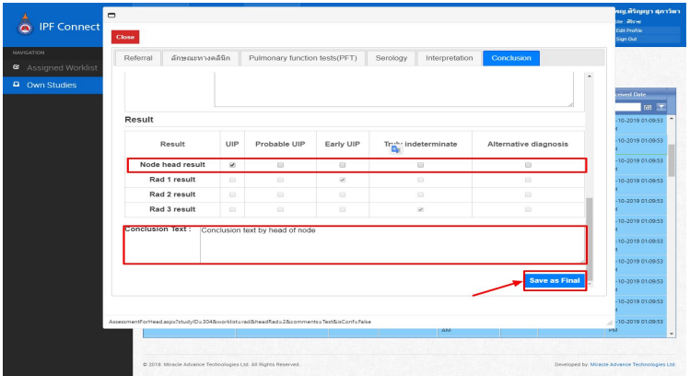

Login as Radiologist

Radiologist user will login using his/her credentials (user id and password).

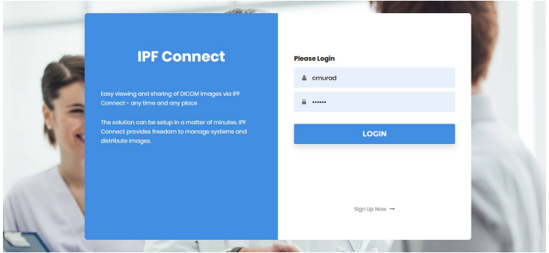

After successful login, the radiologist user will get his/her dashboard. Here user/Pulmo will be able to see the studies which has been assigned to him/her.

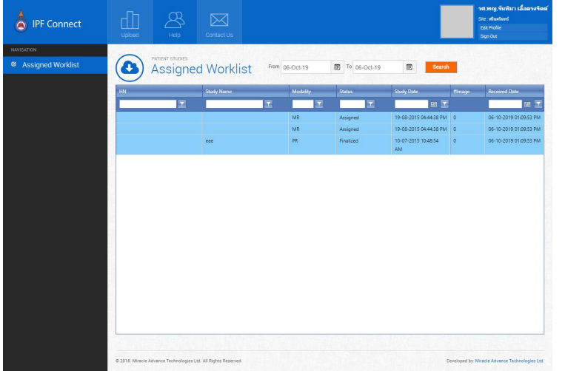

After double clicking on study worklist, the radiologist can able to store interpretation result and comment as draft.

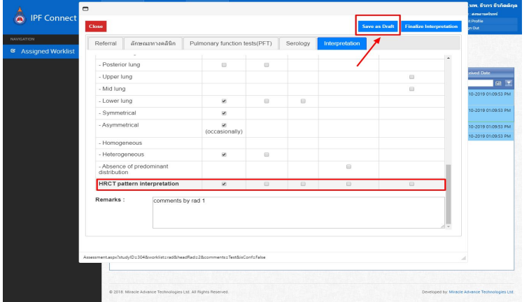

Once user will finalise the study result, PULMO can able to see the result and comments in their worklist.

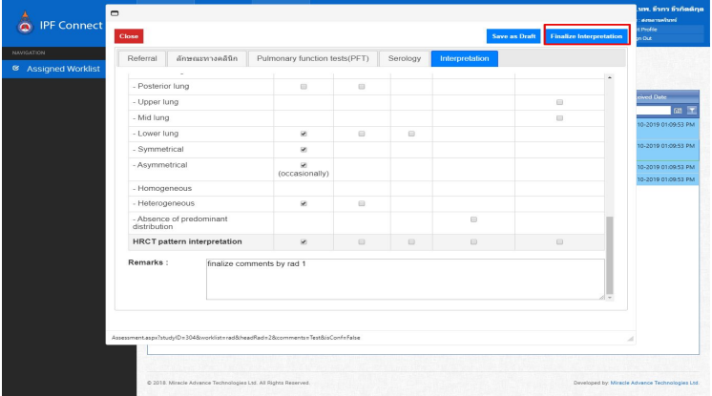

NOTE: The Anonymous user can create a study worklist, but it will auto disappear if the PULMO admin denies the case.

NOTE: The doctor can create a study worklist, but it will auto transfer to another PULMO when PULMO delays accepting that case for seven days.

